**Test Plan:**

**NOT Gate**

|  |  |  |
| --- | --- | --- |
| **Input** | **Expected output** | **Actual**  **Output** |
| **0** | **1** | **1** |
| **0** | **1** | **0** |

**AND Gate**

|  |  |  |  |
| --- | --- | --- | --- |
| **Operand 1** | **Operand 2** | **Expected output** | **Actual Output** |
| **0** | **0** | **0** | **1** |
| **0** | **1** | **0** | **0** |

**OR Gate**

|  |  |  |  |
| --- | --- | --- | --- |
| **Operand 1** | **Operand 2** | **Expected output** | **Actual Output** |
| **0** | **0** | **0** | **1** |
| **0** | **1** | **1** | **1** |

**NOR Gate**

|  |  |  |  |
| --- | --- | --- | --- |
| **Operand 1** | **Operand 2** | **Expected output** | **Actual Output** |
| **0** | **0** | **1** | **1** |
| **0** | **1** | **0** | **1** |

**NAND Gate**

|  |  |  |  |
| --- | --- | --- | --- |
| **Operand 1** | **Operand 2** | **Expected output** | **Actual Output** |
| **0** | **0** | **1** | **1** |
| **0** | **1** | **0** | **1** |

**XOR Gate**

|  |  |  |  |
| --- | --- | --- | --- |
| **Operand 1** | **Operand 2** | **Expected output** | **Actual Output** |
| **0** | **0** | **0** | **1** |
| **0** | **1** | **1** | **1** |

**XNOR Gate**

|  |  |  |  |
| --- | --- | --- | --- |
| **Operand 1** | **Operand 2** | **Expected output** | **Actual Output** |
| **0** | **0** | **1** | **1** |
| **0** | **1** | **1** | **1** |

**Snapshots of CI for Applied SDLC and Testing**

**Git Hub Link:** https://github.com/99002634/Genesis_SDLC

**Badges:**

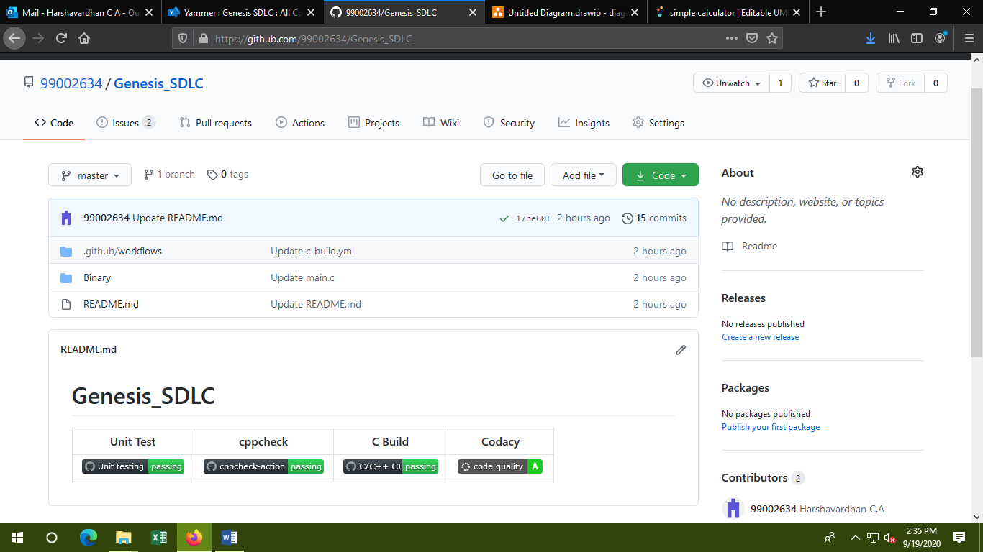

**Commits:**

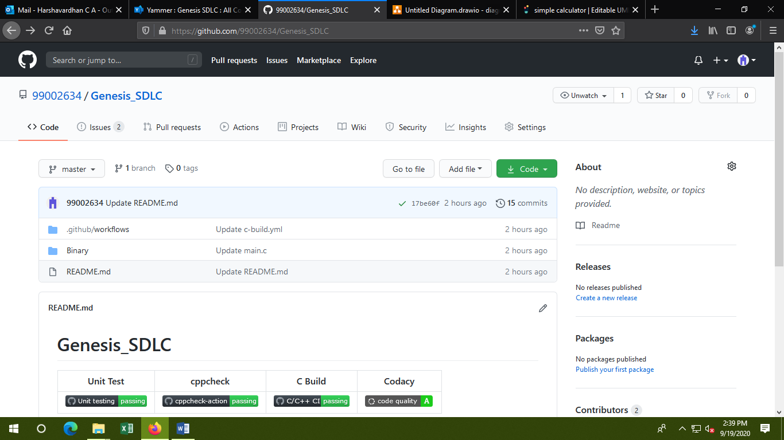

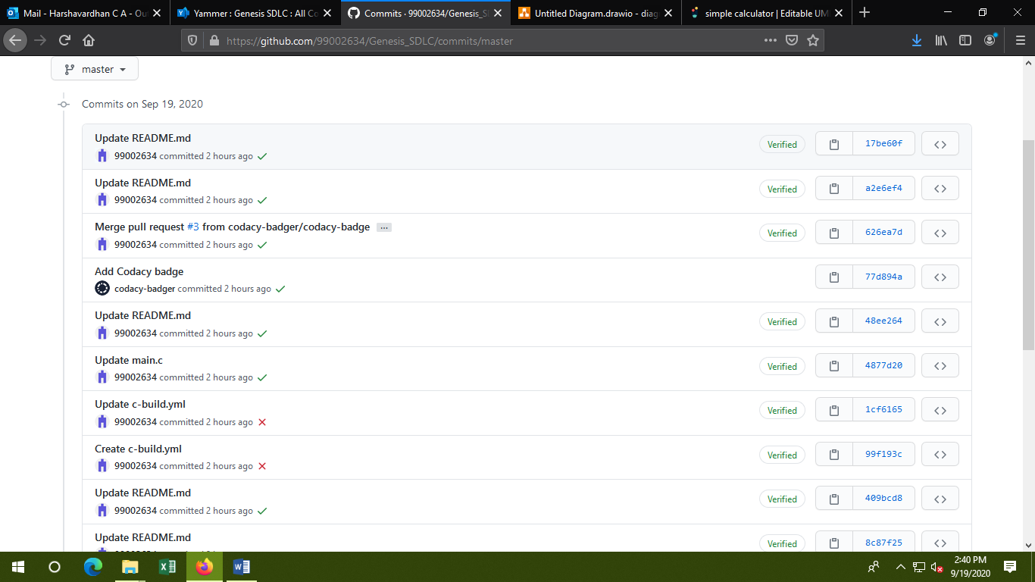

**Actions:**

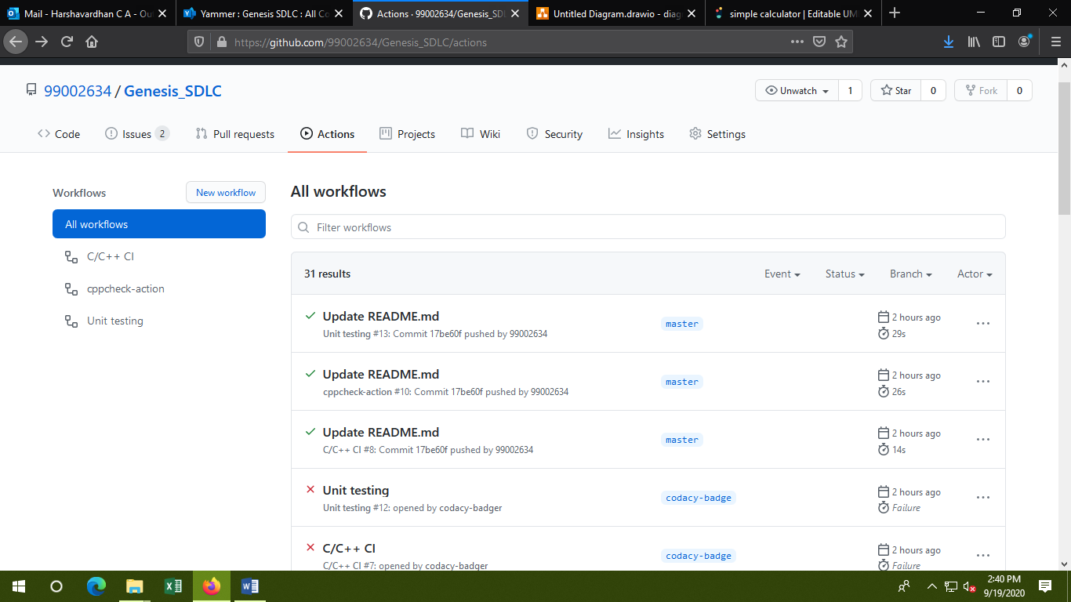

**Issues:**

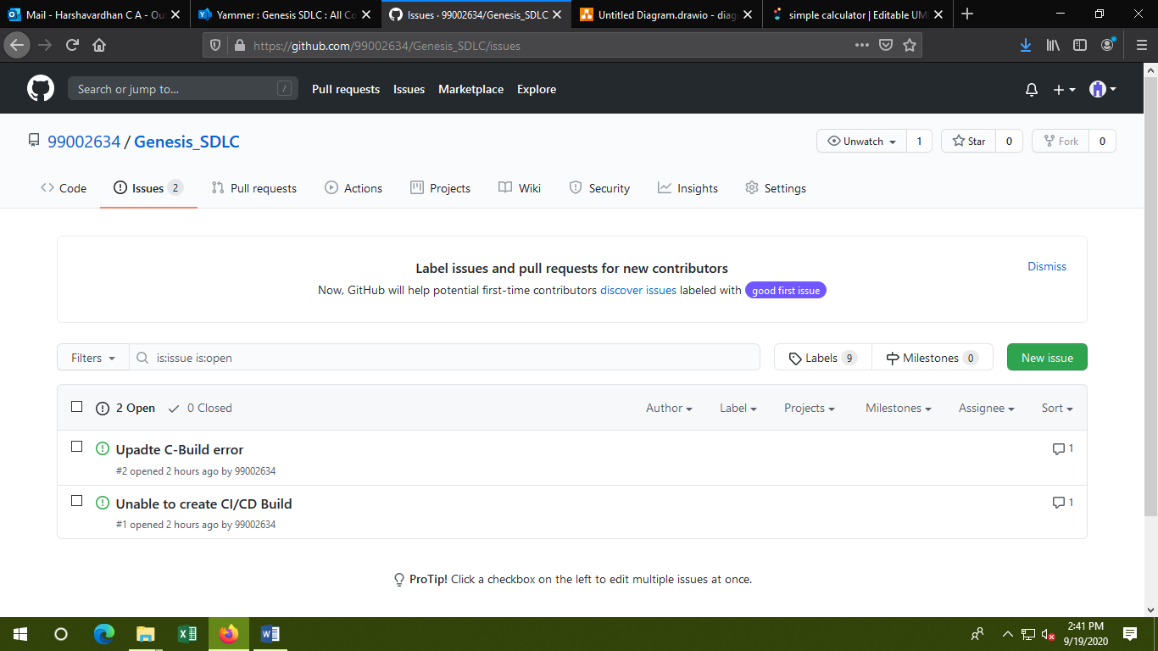

**Test Plan:**

